**Feasibility Analysis (Discussion Portal)**

For our feasibility analysis we did a survey of the members of NIIT University.

**What If the new system was not implemented?**

If the new system wasn’t implemented then the current mailing system will be used for these informal information rather than formal ones.

So, for that informal information our online portal will be used and the current mailing system will be used for other better purposes.

Also, faculty at higher authorities won’t be bothered for these informal requests rather they can post it on our portal.

**What are the current process problems?**

First of all the current process is quite time consuming and also many people who are not related to the mail get bothered due to that. Also the current system is a time consuming process for people at higher authorities such as dean student affairs.

Those people should not be bothered about lost and found of things or mass mailing about an event. If there is a change in the mail then the dean of student affairs has to mass mail it again to everybody which is not user friendly and is time consuming.

**How will the proposed system help?**

This new system will remove the time consuming process of sending a mail and reading it and mass mailing it also people who are not related to some information then they won’t be bothered. People will select the respective section and posts related to that will be shown and users can act on it accordingly.

**What skills this new technology needs?**

This technology needs the current skills of web development which will include PHP, HTML, JavaScript and CSS also UI development using Visual Studio.

**What facilities must be supported by new System??**

The new Technology will be more user friendly, will be more efficient in comparison to previous one and also this technology is more adaptive and reduction of useless cases will take place.

Comparing the Current System and New System….. the responses were as follows :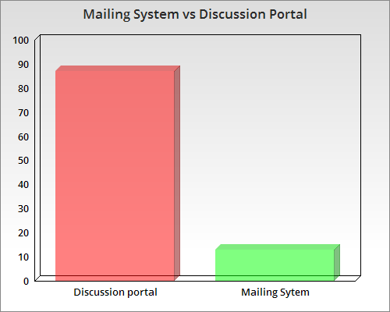

We asked them:

**On a scale of 5 how much would you like to give this idea:**

The response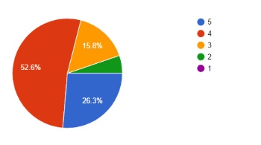

Also we asked them:

**Do you find this idea useful??**

The responses were: